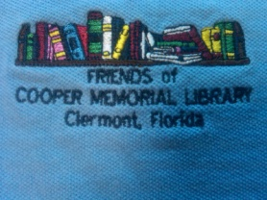
2014 Spring Update
Can you believe that spring is already here! Now that we have officially said good-bye to winter, we welcome the opportunity to refresh, renew and re-energize as The Friends and CML team embark on new and exciting programs for the spring and summer.
Winter Book Sale a Huge Success

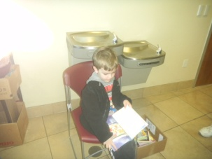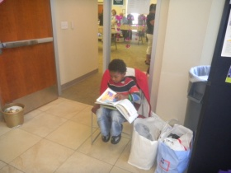
The Friends of CML held their annual winter book sale on February 14-19. Over 900 patrons attended during the week contributing over $6,300 in proceeds. These monies will go towards funding the Children’s Summer Reading Program and many other programs for children, teens, and adults. The most meaningful outcome of the sale was the number of young readers who had an opportunity to browse through a large assortment of books to pick their favorite read(s). The Friends, as well as the CML team, hope that all children will carry this love of reading with them through adulthood.
Stay tuned for more information on our Semi-Annual Book Sale scheduled for August 1-6.
Countdown to a New Addition to the Library
As was mentioned in the winter newsletter, cutting edge technology is being introduced not only to the library but to the community. We are anticipating a new delivery any day now and will let you know as soon as it arrives.
Adopt-A-Magazine Program
We announced earlier that patrons of the library will have an opportunity to maintain and expand the current number of magazines and newspapers now available at the library for children, teens and adults. The Adopt-A-Magazine Program enables patrons, businesses and organizations the opportunity to donate subscription renewals or add new magazines/newspapers. Complete details, together with order forms, will be available shortly.

Korean War Veteran’s Project
The Veteran’s History Project Board of The Cooper Memorial Library will be interviewing Korean War veterans from Clermont, Groveland, Mascotte, Minneola and Montverde. These interviews will be included in the “Collection of Memoirs, Volume 4, Korean War Veterans Part 2.”

Interviews will be held in Clermont at the Cooper Memorial Library, 2525 Oakley Seaver Dr., and the Kings Ridge Clubhouse, Kings Ridge Blvd. If you are interested in participating in this project, please call Audrey Jackson-Morgan on 352-536-9954 or Louise Doak on 352-242-1413, at your earliest convenience, to set up your appointment or to answer any questions you may have. Interviewers and proof readers are also asked to join the group.

Used Books for Sale
Just a reminder to some and news to others that used books are shelved outside of the Children’s Library at Cooper Memorial. There is an assortment of books in both paperback and hard bound editions including romance, mystery, science fiction, fiction, non-fiction, biographies, autobiographies, children’s books, and videos for both children and adults.
We ask only that you leave a donation for your selection of books and/or videos in the mail box which is located on the bookshelf. Sponsored by The Friends of the Cooper Memorial Library, donations are used to fund programs for children, teen, adults, and projects for the library.
Thanks, in advance, for your contributions!
The Cooper Memorial Book Club
The Book Club invites you to read with them on the 3rd Tuesday of each month in Room 221 (Second Floor) from 5PM-7PM. Come join the discussion. Book selections for the remainder of 2014 are as follows:
April – Mrs. Lincoln’s Dressmaker August – Touch & Go
May – The Ocean at the End of the Lane September – Still Alice
June – The Return of the Native October – Unbroken
July – Bad Monkey November – The Secret Keeper
How to become a Friend
Now that you know what we’ve been up to, we’d like to extend to you a special invitation to join The Friends of Cooper Memorial Library. Our meetings are held the fourth Monday of each month. We begin with a social time from 5:00 PM to 5:30 PM. The meetings begin promptly at 5:30 PM and end at 6:30 PM. During the meetings we plan projects, events, and activities to raise extra funds for our library. The 2014 regular membership fee is $15, and the student fee is $2.

